CMC Lab 02 - Distributed Consistency

and Consensus in the Cloud

Name : Mazen Yasser

Group : SE2

Overview
This report documents the execution of the lab using Docker Compose, Redis replication, and etcd (Raft consensus).

Task 1: Redis Replication and CAP
Docker Compose started containers successfully.
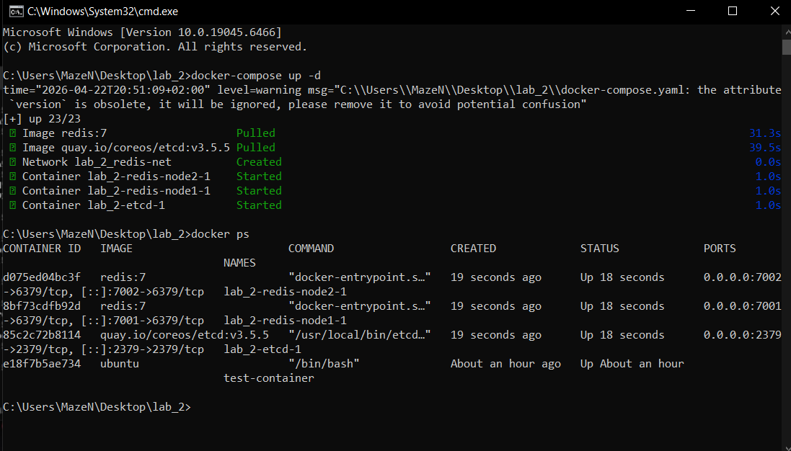

Connected to redis-node1 and set keys name=Mazen and city=Cairo.
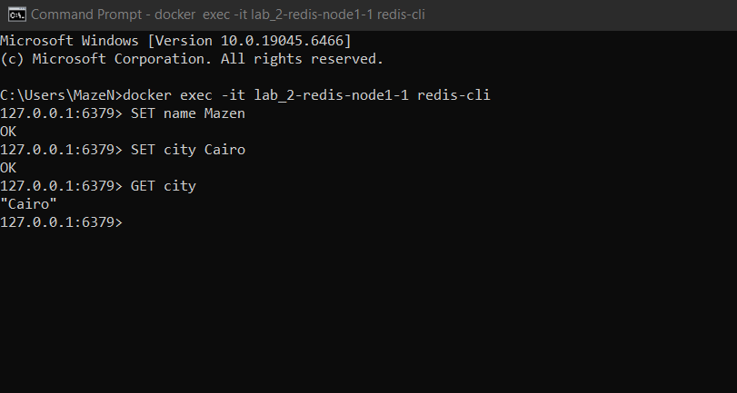

Connected to redis-node2 (replica) and verified keys replicated from node1.
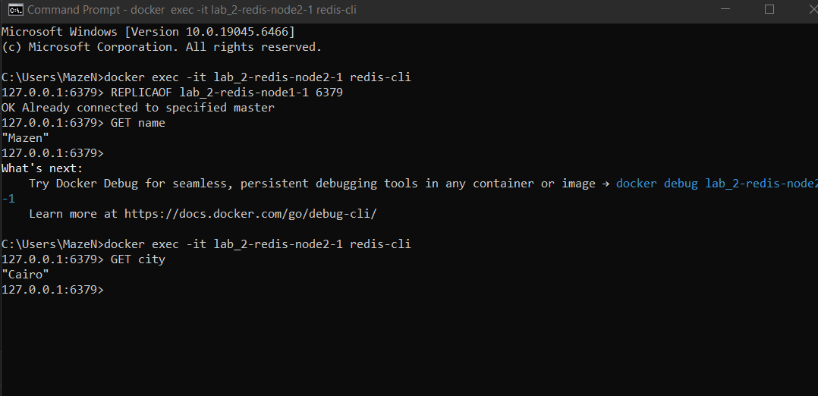

Stopped and restarted redis-node2 to simulate temporary partition.
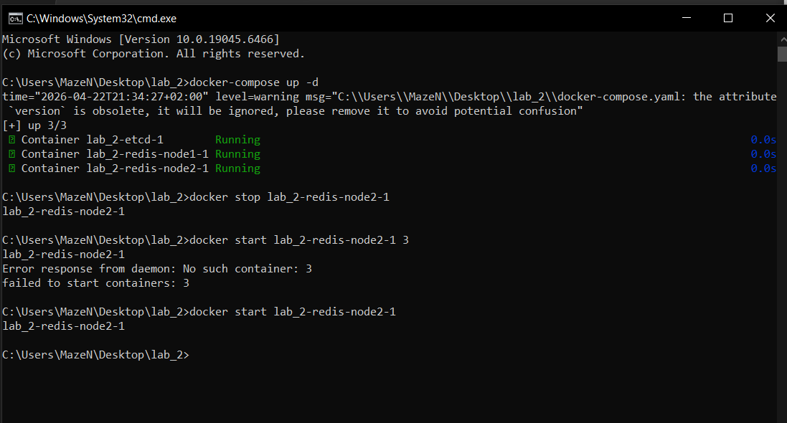

Task 2: Raft with etcd
Used etcdctl put/get and checked endpoint status showing information.
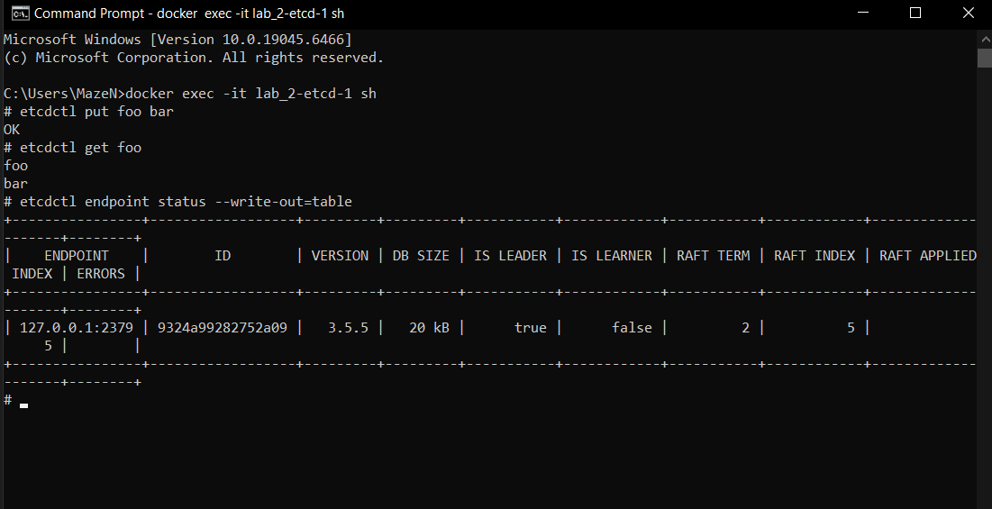

Cleanup
The environment was stopped using docker-compose down.
